*Florida International University*

*School of Computing and Information Sciences*

CIS 4911 - Senior Capstone Project

Software Engineering Focus

Feature Document

User Story # 671

**Team Member:**

Garrett Lemieux

**Product Owner(s)**:

Francisco Ortega

**Mentor(s)**:

Francisco Ortega

**Instructor**: Masoud Sadjadi

**User Story – Implement functionality for Real Sense Device**

* As a User I would like to be able to use Real Sense Device in Paint Program in order to allow for more interactive experiences with smart desk.
* **Acceptance Criteria**:
  1. User can perform a facial gesture such as a double eyebrow raise and action occurs in program.
  2. User can perform a facial gesture such as a kiss gesture and action occurs in program.

**Use Case: User performs face gesture**

User wants to perform a face gesture that will perform an undo operation.

* Details:
* Actor:
  + User
* Pre-conditions:
  + TouchPoint app is running.
  + Real Sense Device
* Description:
  + Use case begins when User has decided to perform face gesture
  + User can perform undo function by performing a kiss gesture or a double eyebrow raise gesture.
  + Use case ends when user sees a previously drawn line disappear.
* Post-conditions:
  + TouchPoint app is running
  + Real Sense device connected
* Decision Support:
  + Frequency: Medium, User may want to change modes using Real Sense facial gesture but can also perform same undo function using touch screen.
  + Criticality: Medium, Other devices can do undo function.
  + Risk: High , First time working with Real Sense
* Usability:
  + Needs to know how a kiss gesture is performed.
  + Needs to know how a double eyebrow raise gesture is performed.
  + Needs to know what function the gestures perform.
* Reliability
  + High
* Performance
  + Performance High
  + Failure Low
* Supportability
  + Real Sense Device
* Modification History:
  + Owner: Garrett Lemieux
  + Initiation Date 3/29/2016
  + Date last Modified: 05/5/2016

**Use Case Diagram**

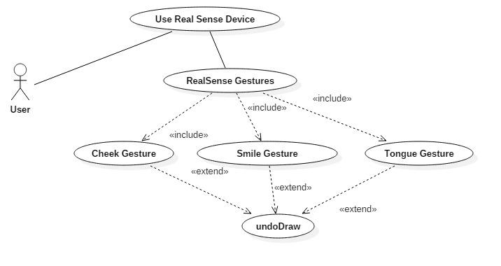

**Sequence Diagram**

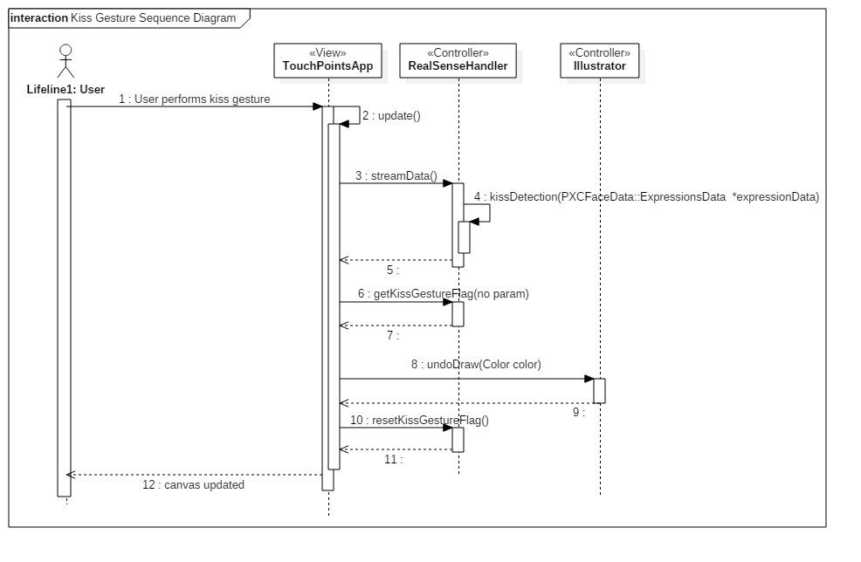

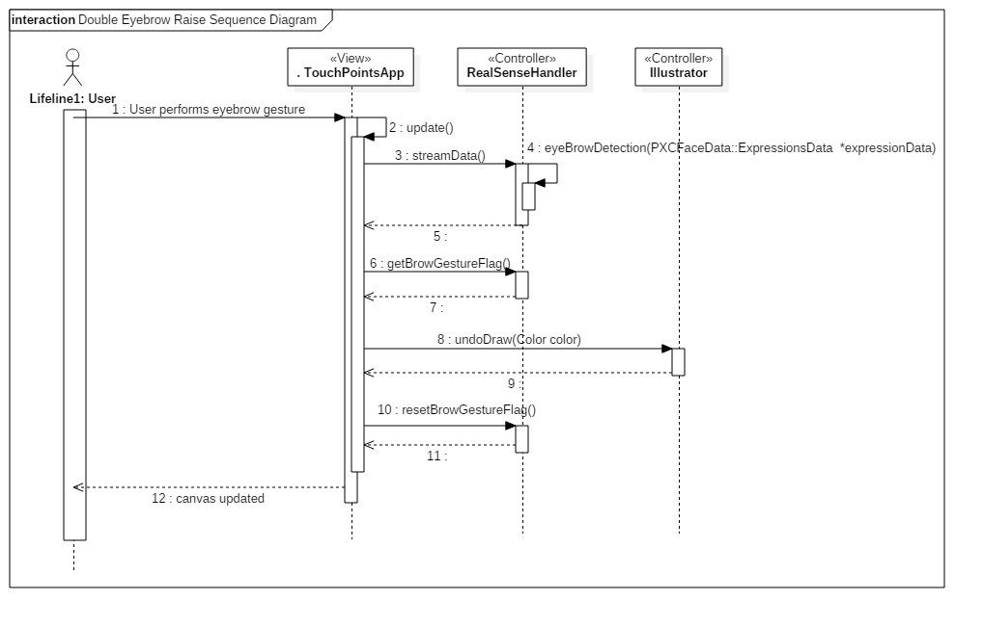

**Class Diagram**

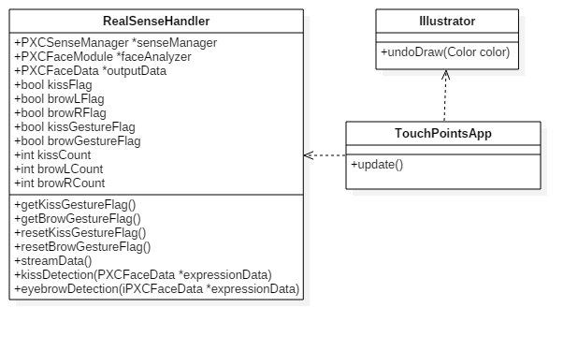

**Unit Test**

* Sunny Day Test:
  + Test Case  - Kiss Gesture Read by Real Sense
    - Test Purpose: To determine if Real Sense correctly reads kiss gesture.
    - Test Procedure: User starts program and draws three lines or three shapes starting from the left side of canvas. He or she then performs a kiss gesture and holds gesture for at least one second. Observes results then performs another kiss gesture for one second. Observes results and then performs a kiss gesture a final time and observes results.
    - Expected Results: After kiss gesture performed for the first time the line or shape farthest to the right should disappear. After second time kiss gesture performed line or shape farthest to the right should disappear. After kiss gesture performed for a third time all lines and shapes should have been removed.
  + Test Case  - Double Eyebrow Raise Gesture Read by Real Sense
    - Test Purpose: To determine if Real Sense correctly reads double eyebrow raise gesture.
    - Test Procedure: User starts program and draws three lines or three shapes starting from the left side of canvas. He or she then performs a double eyebrow raise gesture and holds gesture for at least one second. Observes results then performs another double eyebrow raise gesture for one second. Observes results and then performs a double eyebrow raise gesture a final time and observes results.
    - Expected Results: After double eyebrow raise gesture performed for the first time the line or shape farthest to the right should disappear. After second time double eyebrow raise gesture performed line or shape farthest to the right should disappear. After double eyebrow raise gesture performed for a third time all lines and shapes should have been removed.
* Rainy Day Test:
  + Test Case  - User Accidently performs kiss gesture
    - Test Purpose: Test if accidently kiss gesture is read by Real Sense.
    - Test Procedure: User starts program and begins to draw lines. He or she then performs a quick kiss gesture that lasts less than one second.
    - Expected Results: Nothing should happen and canvas should not be altered. If item drawn disappears then kiss gesture was read and test fails.
  + Test Case  - User Accidently performs double eyebrow raise gesture
    - Test Purpose: Test if accidently double eyebrow raise gesture is read by Real Sense.
    - Test Procedure: User starts program and begins to draw lines. He or she then performs a quick double eyebrow raise gesture that lasts less than one second.
    - Expected Results: Nothing should happen and canvas should not be altered. If item drawn disappears then double eyebrow raise gesture was read and test fails.

**Integration Testing**

* The ability to use the kiss gesture and double eyebrow raise gesture with Real Sense while all devices are connected is successful.
* The kiss gesture was used to “undo” previously drawn lines or shapes. After performing kiss gesture the previously lines or shapes drawn successfully disappeared. This was tested for all shapes and colors along with items drawn using leap motion and multitouch screen.
* The double eyebrow raise gesture was used to “undo” previously drawn lines or shapes. After performing double eyebrow raise gesture the previously lines or shapes drawn successfully disappeared. This was tested for all shapes and colors along with items drawn using leap motion and multitouch screen.
* After integrating double eyebrow raise gesture and kiss gesture into the application all previous functionality was maintained and functioning correctly.

**User Guide**

* User must have the Real Sense plugged in.
* The user can perform a kiss gesture as shown below.
* Before Gesture:

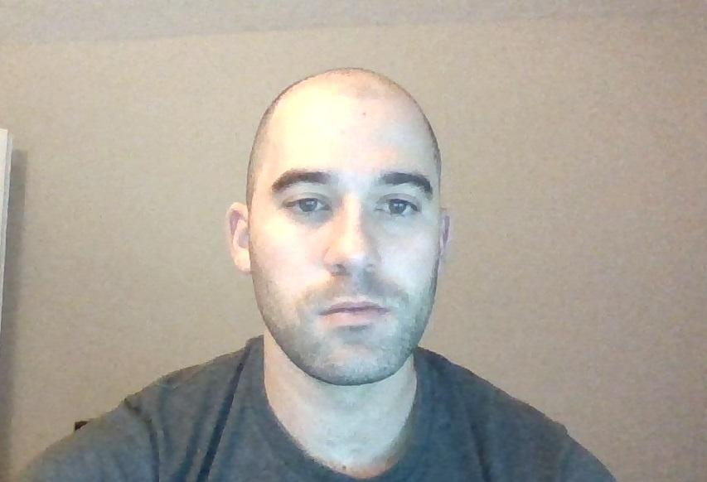

* Kiss Gesture:

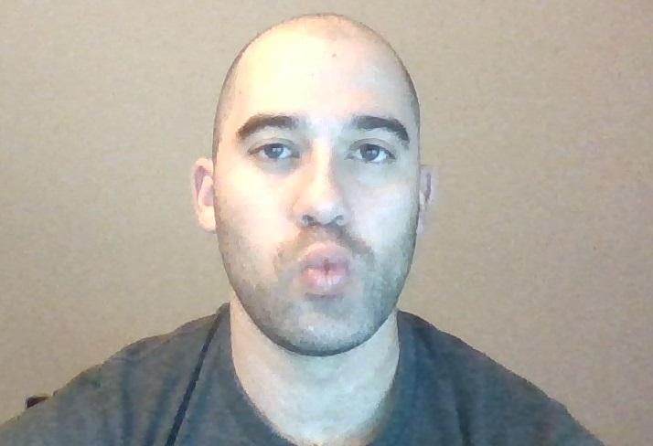

* Once the user holds the gesture for at least one second the previously drawn line or shape will be removed.
* The user can perform a double eyebrow raise as shown below.
* Before Gesture:



* Double Eyebrow Raise Gesture

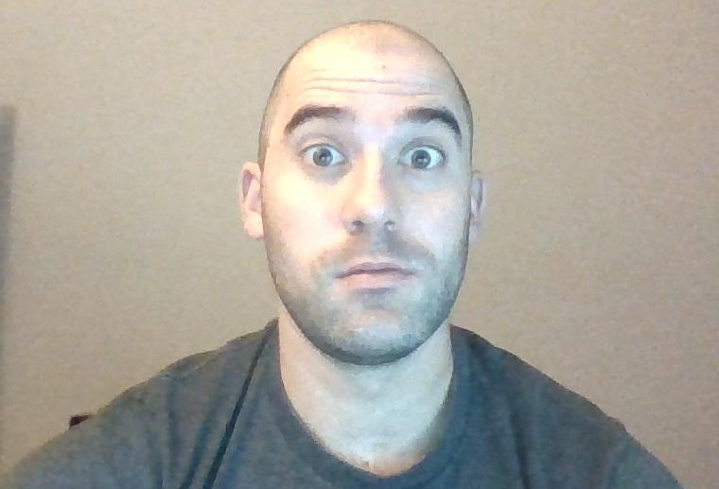

* Once the user holds the gesture for at least one second the previously drawn line or shape will be removed.

**Glossary**

* **N/a**